**Health Worker**

In our proposed system the efficiency and accuracy depends on the survey system. To convey this survey we have two persons (H.A and F.W.A. in current system) in every Community Clinic (C.C) (i.e. for every 6000 people). In our system we label them as Health Worker (H.W.).They perform their survey according to the automated Schedule provided by the system. H.W. is bound to Health Inspector (H.I.) for his activities.

**Health Workers Job:**

1. Updating Eligible Couple List(E.C.L.)
2. Pregnant Women Identification (P.W.I.) and Updating their Profile
3. Providing P.N.C.
4. Providing A.N.C.
5. Family Planning Consultancy(F.P.C.)
6. Vaccination
7. Inform Death Report
8. Suggesting Location of Satellite Clinic

**Profile:**

Every H.W. maintains a profile which helps to track his activities and rank him. His profile has the following tabs:

1. **Basic Information:**

This field contains basic information of a H.W. This is visible to his Up-line personals. ID, Name, Location, Date of birth, Sex, Ranking of Performance etc. basic info are under this sector.

1. **Performance:**

Here the performance (graphically or statistically) of a H.W. is displayed. This can be viewed both as monthly and daily base. H.I. can get clear idea of the activities of a H.W. from this sector. This performance is displayed in the basis of H.W.’s capability or efficiency in his scheduled job completion. Ranking and Suggestion of training are also displayed here. This sector is also visible to the Up-line personals.

1. **Job Schedule:**

After login to his profile a H.W. can see his daily work plan. The houses that are assigned to be visited are displayed in this sector. This work plan is displayed in two format- **Map view** and **Stack view**.

In **Map View** scheduled houses are displayed as a white dot with a tag regarding necessary services (*F.P.C. or Vaccination or P.N.C. or P.W.I.*) needed to be provided in that house in a map. Colors of these dots change in different stages of job completion.

In **Stack View** information ofscheduled houses are displayed in a stack. Location, service receiver’s state, service info etc. are displayed as an element of that stack. A complete job goes down (out) to the stack.

After his visit H.W. updates his client’s profile (Service info part- i.e. A.N.C., P.N.C., Vaccination, S.C. selection etc. info).*There is a link between the Service Info part of the client with this work plan view so that H.W. can update his clients info just after his visit with his mobile*. This job schedule field is only visible to H.W. This is designed for both mobile and desktop module (for updating Service Info part from C.C.).

1. **Updating E.C.L.:**

This is an important part of H.W.’s job. During his survey if he is acknowledged of a new eligible couple, he’ll update the existing E.C.L. with this new entry. He can entry the couple at the spot (couple’s location) with his mobile or create a blue dot with a tag regarding the couple’s identification in the map and update further information from C.C.

1. **Death Report:**

Death of a woman or a child in the respected area needs to be informed. During the survey H.W. take the information regarding the death and report his supervisor about this incident. The report contains dead person’s name, location, reason of death etc.

1. **Satellite Clinic Location Suggestion:**

In this field he suggests his H.I. about the possible location of Satellite clinic. He can tag some suitable locations in map. His suggestion is visible to his Up-line personals.

**Verification:**

H.W. sends update notification to his supervisor (H.I.). H.I. verifies H.W.’s work and updated data and after his confirmation database is updated. This verification process goes through the following steps:

1. Tracking whether H.W. has visited the scheduled families or not by GPS tracker.
2. Overall report and data updating from H.W. If any problem in data collecting then H.W. will notify about regarding problem and system will reschedule the visit to respected houses.
3. Another automated phone call to the respected couple to ensure the visit of the H.W.

For assuring the participation of the couples an automated phone call will notify the couples, two days before the survey of H.W.

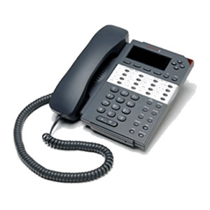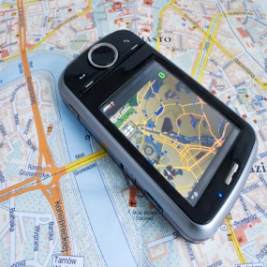

**Notification -> Tracking -> Data Updating -> Feedback**

** If anyone suspects their pregnancy, they can call to the hotline number and inform their pregnancy. H.W. will be sent to justify their claim and pregnant database will be updated according to their report.